**HARISH GANESAN**

**UB Person No: 50249122**

**Computer Vision and Image Processing**

**Homework 2**

**Scale-space blob detection**

**There are 2 files which contain the code related to this homework :   
final_code.m and down_sample.m. They are present in the folder “matlab”.**

**The first one contains the method where we change sigma for each slice in the scale space.**

**The second code contains the method where we downsample the image and then filter it with sigma as a constant.**

Below is the table containing all the runtimes for the pictures for method 1 (changing sigma) and method 2 (downsampling) respectively.

We can see that in all the images, the second method is consistently better than the first in terms of the time it takes to run the program. This is because in the first method we increase the scale factor exponentially, and this leads to the image being filtered with a larger window everytime, and this increases the amount of time the program takes to execute.

Also, in the second method, when we downsize the image, the filtering needs to be done on lesser and lesser number of pixels each time as we are scaling the image down by a factor of k. Hence we have fewer pixels to process each time we filter the image.

|  |  |
| --- | --- |
| **Einstein1** | **4.821 s** |
| **Einstein2** | **1.370s** |
| **Butterfly1** | **3.1811s** |
| **Butterfly2** | **0.789s** |
| **Sunflowers1** | **2.557s** |
| **Sunflowers2** | **0.504s** |
| **Fishes1** | **3.18s** |
| **Fishes2** | **0.548s** |
| **Penguin1** | **1.833s** |
| **Penguin1** | **0.2686s** |
| **Firework1** | **1.696s** |
| **Fireworks2** | **0.372s** |
| **Lamp1** | **4.433s** |
| **Lamp2** | **1.028s** |
| **Animals1** | **1.687s** |
| **Animals2** | **0.464s** |

* In this implementation, I chose the “sigma” value to be 2, because taking the default value of 0.5 leads to the circles being too small.
* The “threshold” value was determined to be 0.003 based upon multiple rounds of trial and error, and this value leads to the right amount of circles being displayed on the screen ( done upon comparing with sample outputs provided).
* The “n” value is 15 because we can pick any value between 10 and 15, and 15 gives us more elements in our scale spaces to do our computation, so that is the value that was picked.
* The scaling factor was set to 1.18 because 2 is too big as the scale rises exponentially, and it takes more time to run with scale factor at 2. A scale factor of 1 will lead to no scaling at all, so we need to pick one such that the scaling increases only gradually.

Below, there are 8 original images with 2 resultant images with blobs in them for each of the two methods.

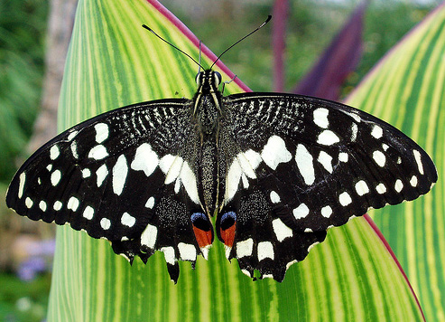  
ORIGINAL  
  
  
  
  
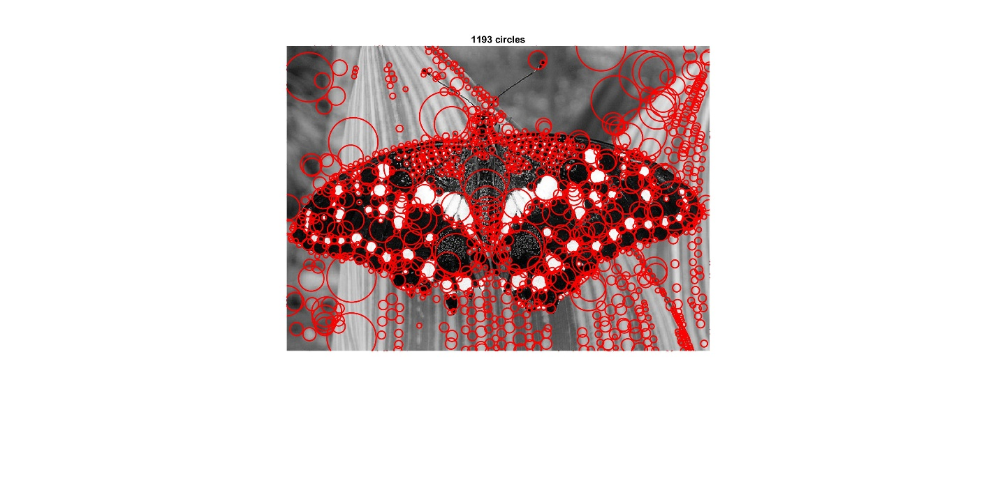

METHOD 1 – SIGMA CHANGE

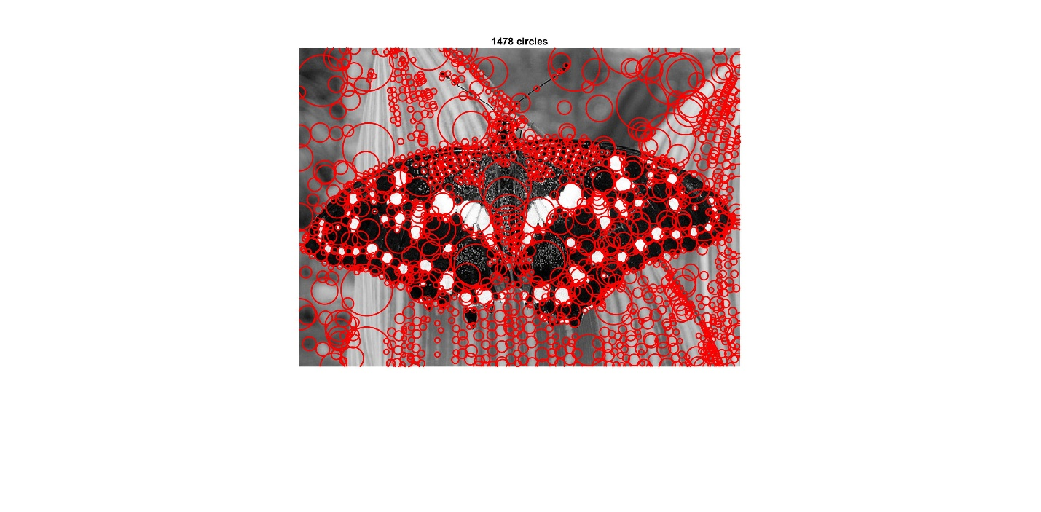

METHOD 2 – DOWNSAMPLE

ORIGINAL  
  
  
  
  
 METHOD 1 – SIGMA CHANGE METHOD 2 – DOWNSAMPLE

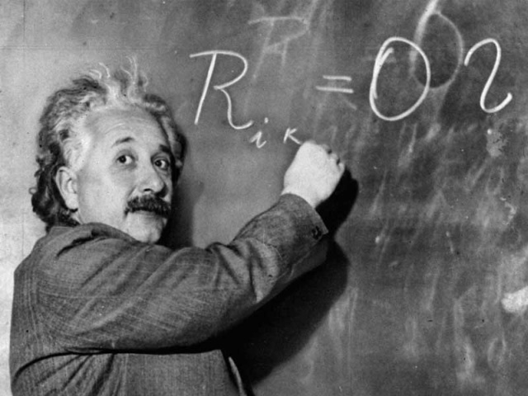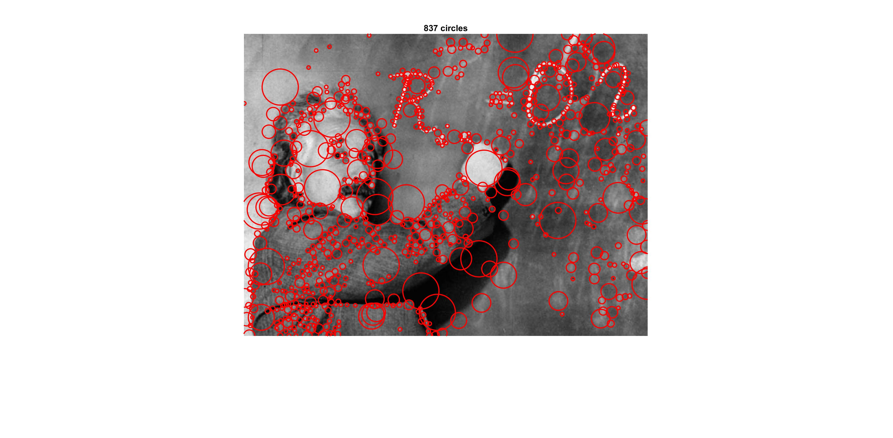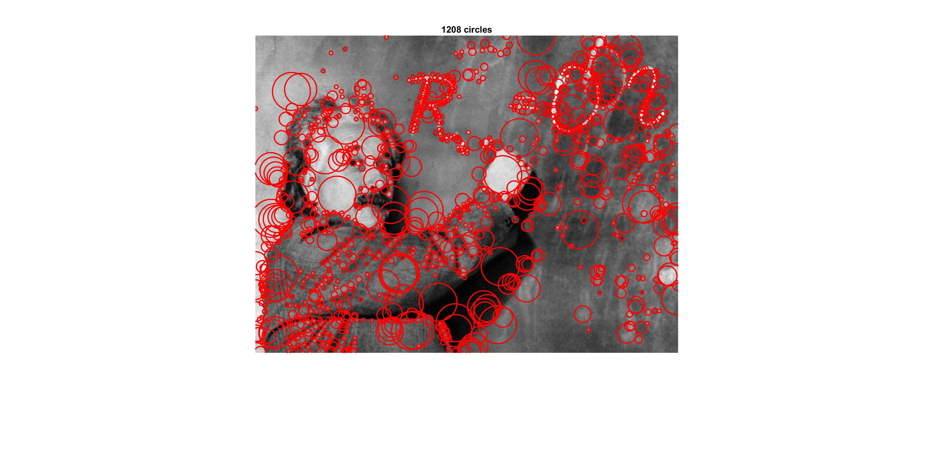

ORIGINAL  
  
  
  
METHOD 1 – CHANGE SIGMAMETHOD 2 – DOWNSAMPLE

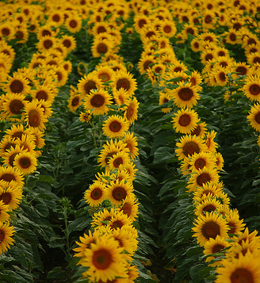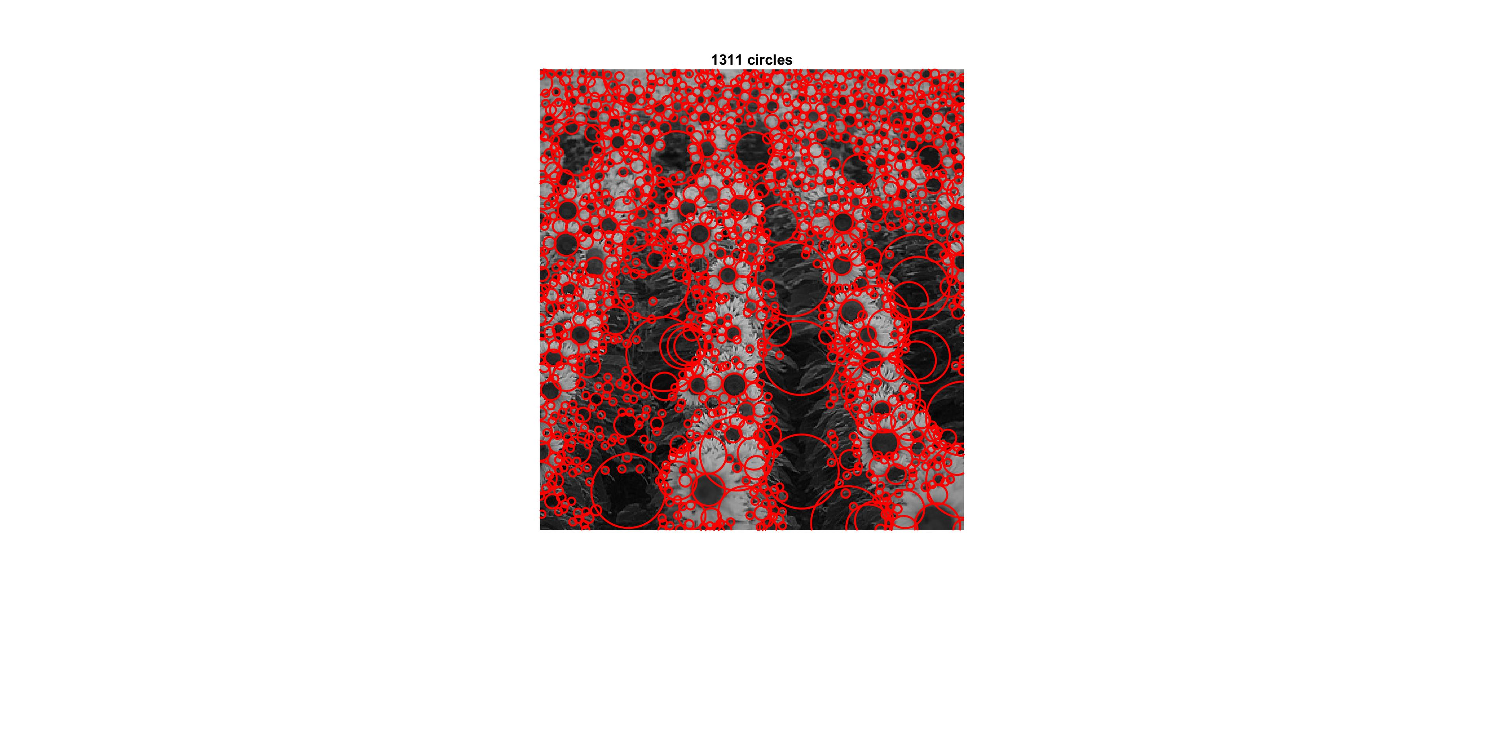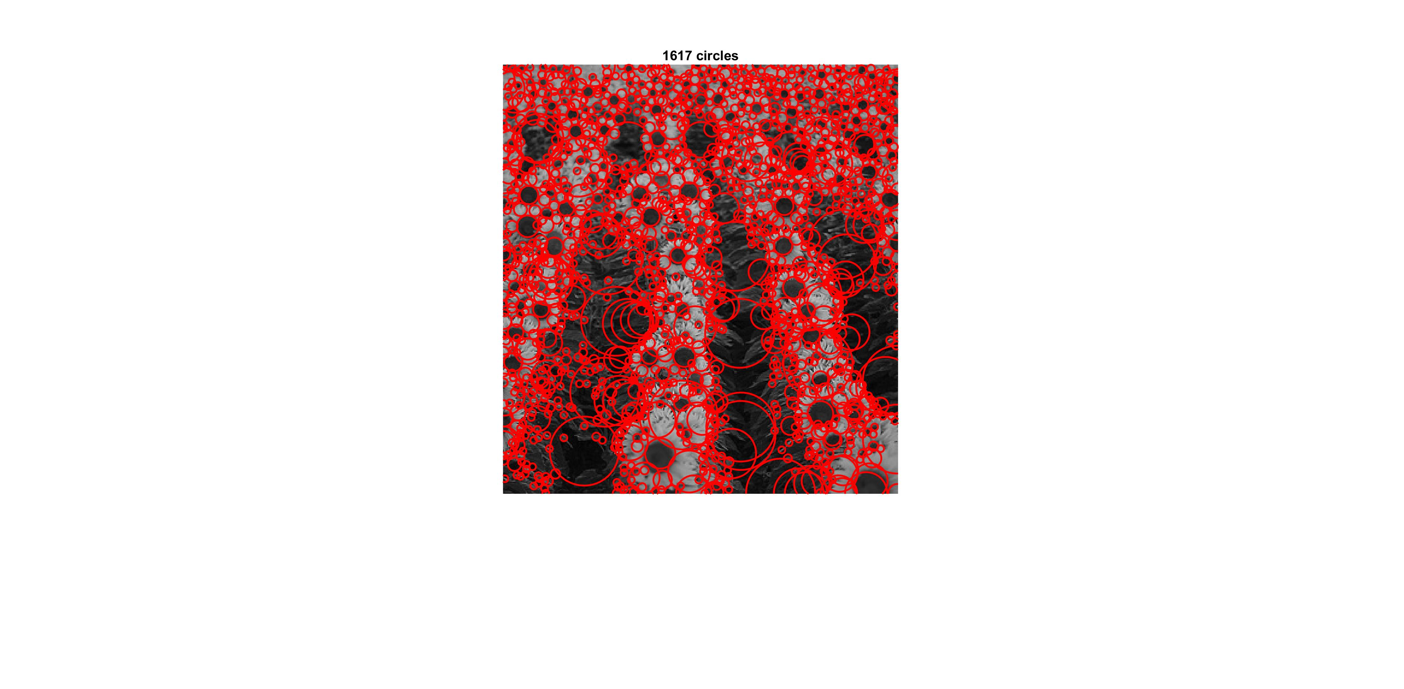

ORIGINAL  
  
  
  
  
  
METHOD 1 – CHANGE SIGMA   
METHOD 2 – DOWNSAMPLE

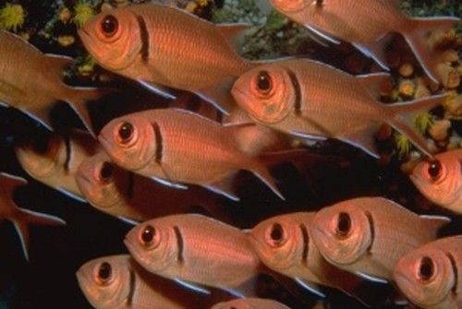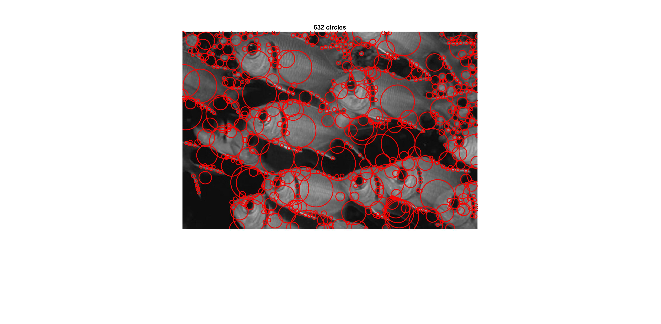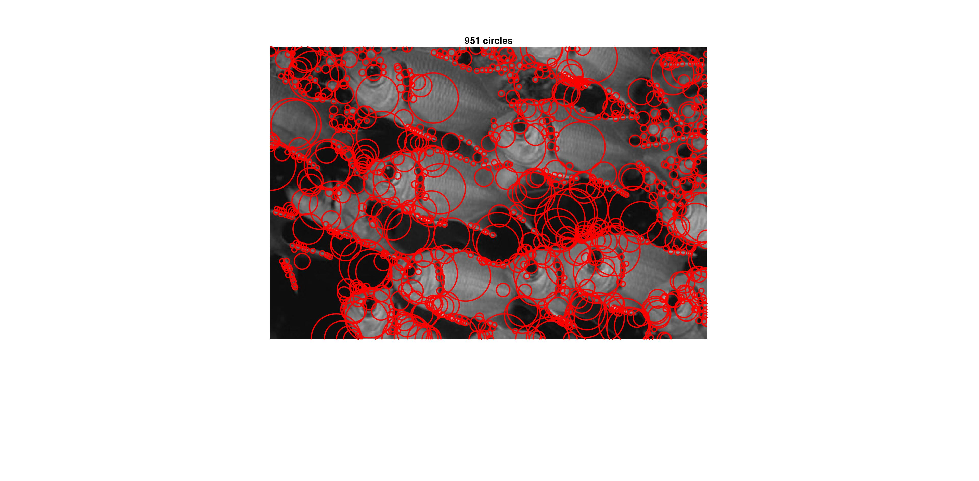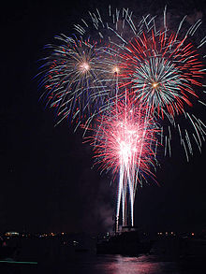

ORIGINAL  
  
  
  
 METHOD 1 – CHANGE SIGMA

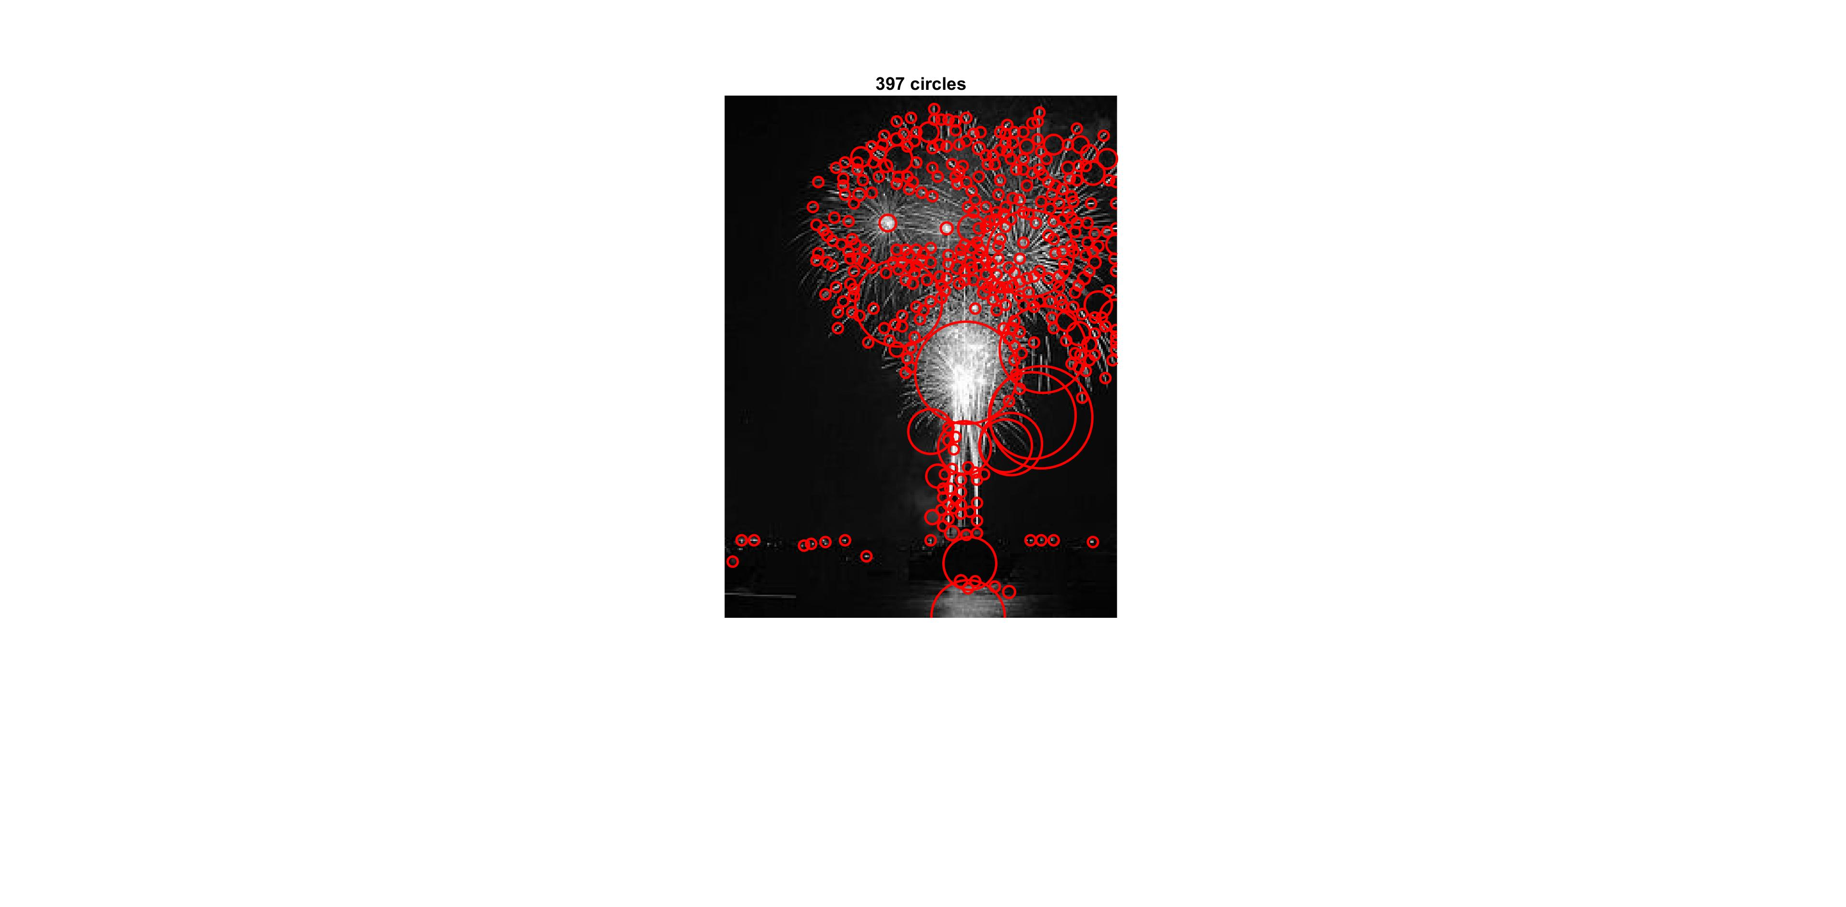

METHOD 2 - DOWNSAMPLE

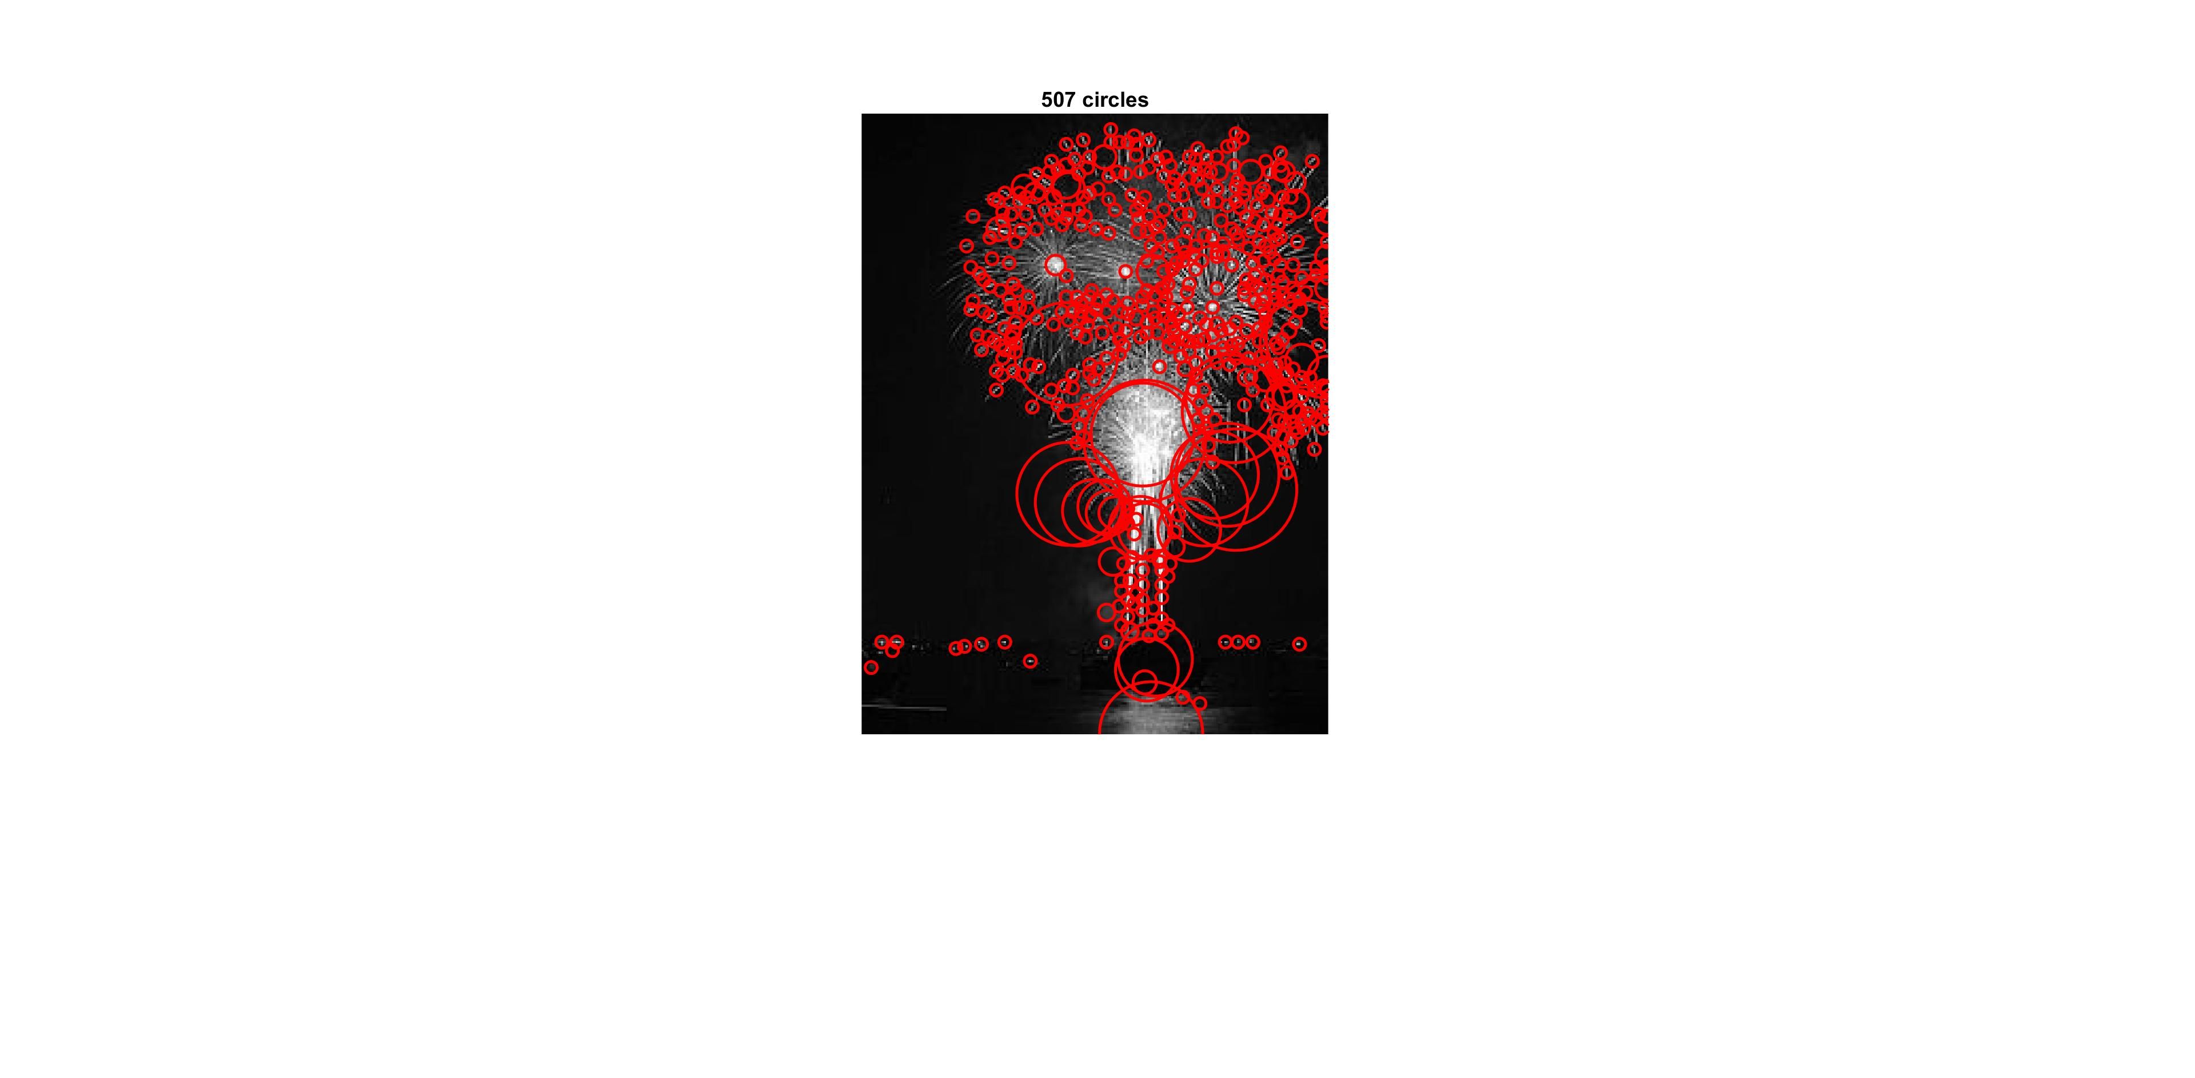

ORIGINAL  
  
  
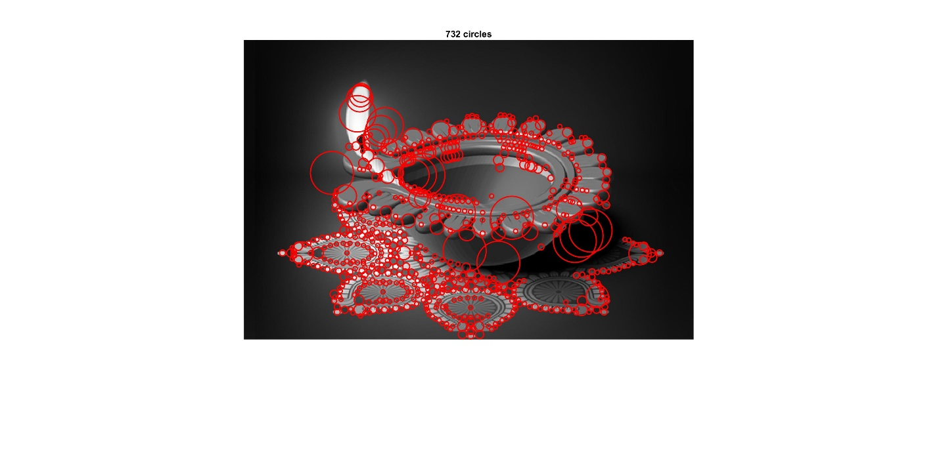



METHOD 1 – CHANGE SIGMA

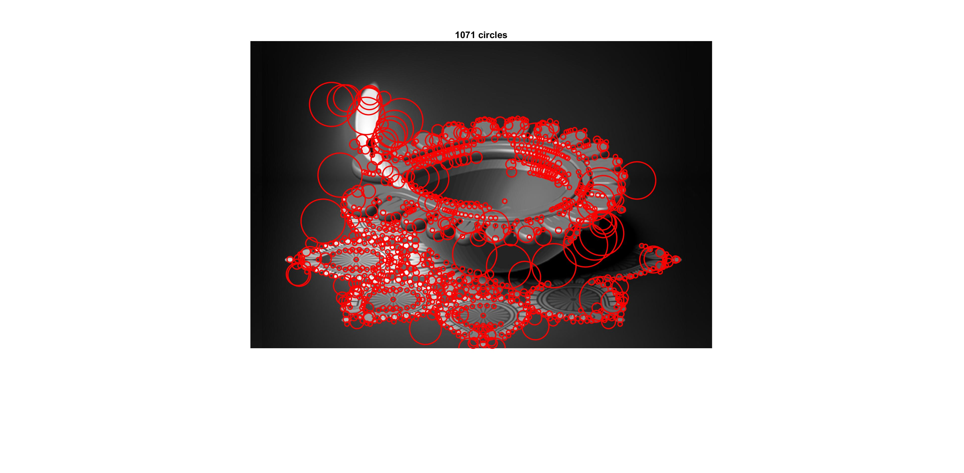

METHOD 2 – DOWNSAMPLE

ORIGINAL  
  
  
  
 METHOD 1 – CHANGE SIGMA

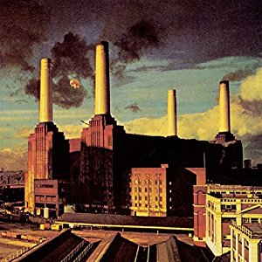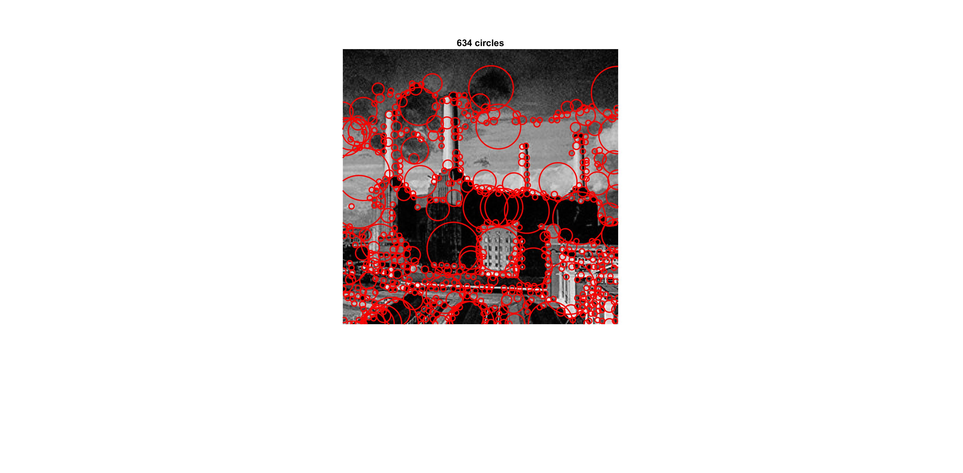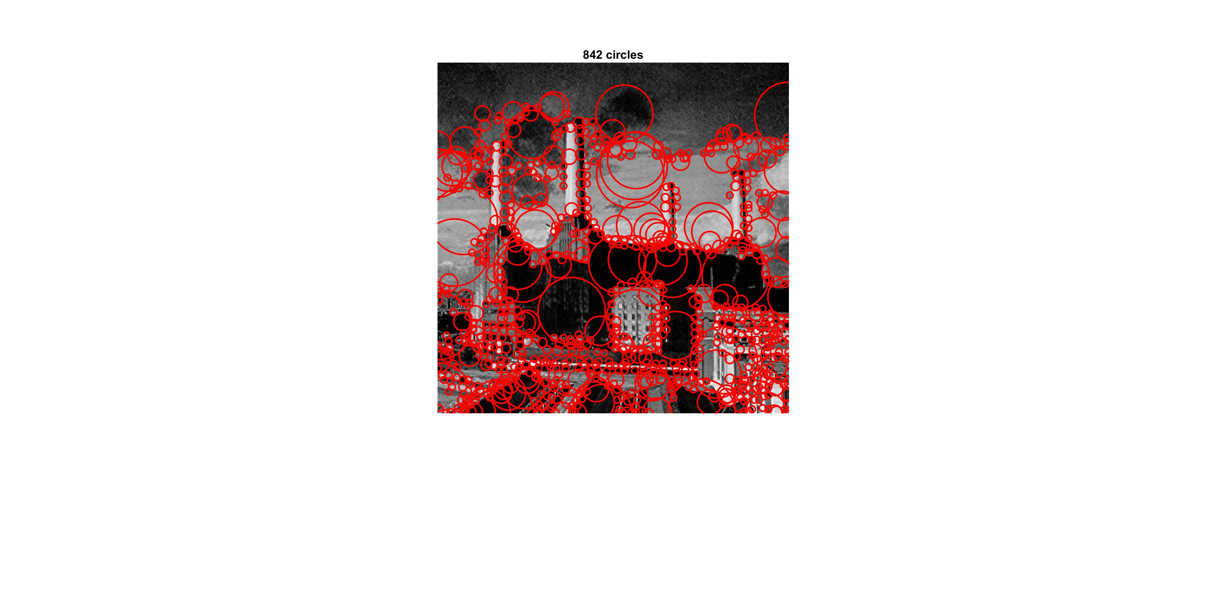

METHOD 2 - DOWNSAMPLE

ORIGINAL  
  
METHOD 1 – CHANGE SIGMA

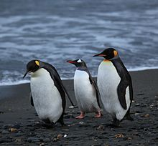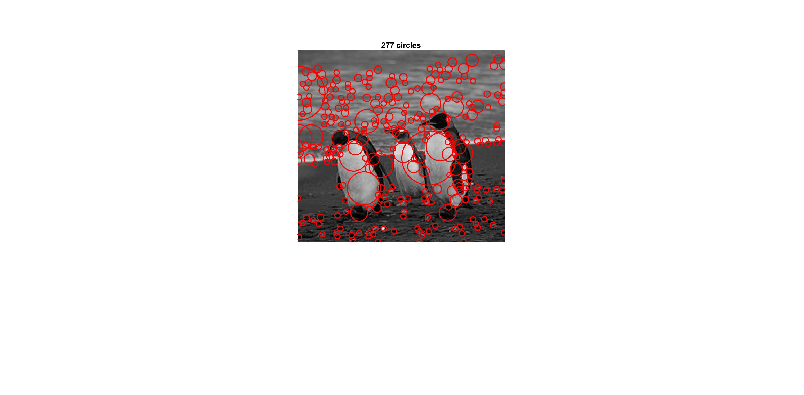

METHOD 2 - DOWNSAMPLE

